
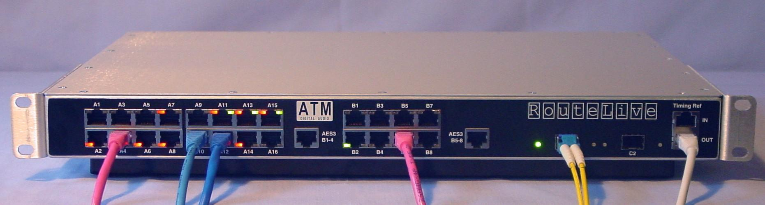
ATM edge switch supporting live-to-air streaming
- CBR and UBR services to support AES47
- throughput: 3.6 Gbit/s non-blocking
- routes different sample rates simultaneously
- LEDs indicate when live-to-air traffic is flowing
RouteLive switch specifications

Front panel connectors
- 100 Mbit/s ports (A1-A16 on RL01-312 pictured above)
- RJ45, standard Ethernet pinout
- auto-MDIX (no cross-over cables needed)
- automatically selects between loop-through to Ethernet network and ATM-over-Ethernet service
- 155 Mbit/s ATM ports (B1-B8)
- RJ45
- pins 1,2,7,8 ATM data
- pins 4,5 “emergency AES3”
- pins 3,6 timing reference signal output
- 622 Mbit/s ATM ports (C1-C2)
- fibre, SFP modules
- transmission distance: 0.5, 2, 15, or 40 km
- All network ports
- two tri-colour LEDs per port
- LEDs show which ports are live-to-air
- “Emergency AES3” ports
- RJ45
- one pair connects to each of four ATM ports
- direct connection, effective even when power off
- pins 4,5 connect to port 1 or 5
- pins 1,2 connect to port 2 or 6
- pins 3,6 connect to port 3 or 7
- pins 7,8 connect to port 4 or 8
- Timing reference
- RJ45 input carries up to four separate copies
- signal from pins 3,6 distributed to ATM ports
- separate buffer amplifier for each ATM port
- other pairs routed to RJ45 “out” connector
- single cable from main distribution amp can feed up to 4 switches by daisy-chaining “out” to “in”

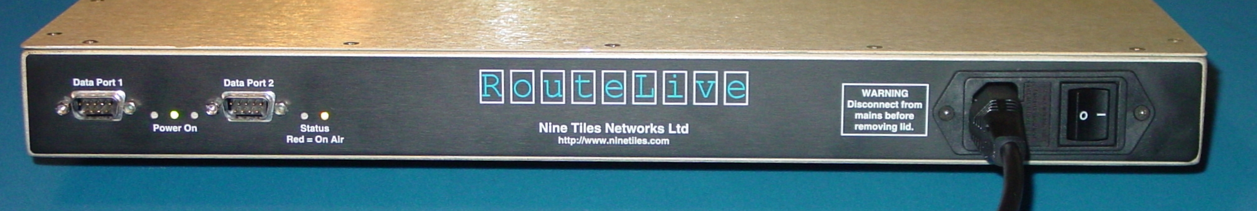

Back panel connectors and LEDs
- Two RS232 serial ports
- 9-way D-plug connectors
- baud rates up to 115,200
- Status indication
- two tri-colour LEDs
- shows whether the switch is live-to-air
- Mains power inlet
- switched and fused IEC connector
- 85-265V AC, 47-440Hz
Mechanical
- 19” rack mount unit
- 1U high
- 350mm deep
Configuration options
- RL01-112
- 16 ports 155 Mbit/s ATM over UTP
- 2 ports 622 Mbit/s ATM over fibre
- RL01-312
- 16 ports “Brunhilde” ATM service over 100 Mbit/s Ethernet physical layer
- 8 ports 155 Mbit/s ATM over UTP
- 2 ports 622 Mbit/s ATM over fibre
ATM services
- UNI 3.0, 3.1, and 4.0
- ILMI 4.0
- Additional messages defined by ATMAVA to support live-to-air traffic (proposed future IEC 62379 standard)
- CBR and UBR SVCs

RouteLive extension box specifications
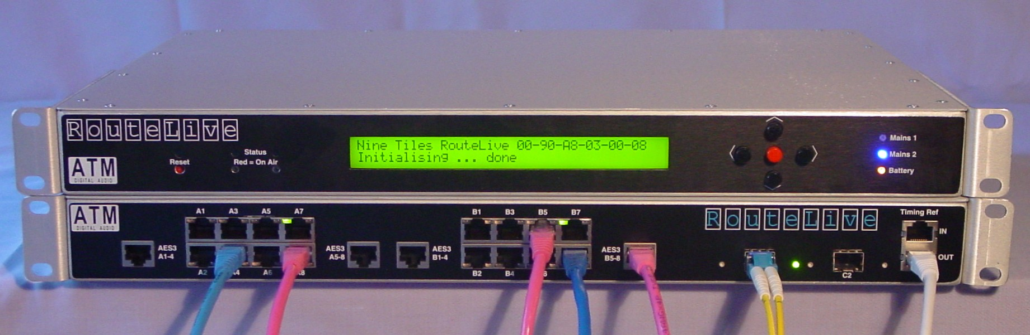

Back panel connectors
- Two mains power inlets
- fused IEC connector
- 90-264V AC, 47-63Hz
- 25-way D-socket
- link to switch (cable supplied)
- supplies 24v power to switch
- connects switch processor to display etc
Front panel
- 2 lines × 40 characters LCD display provides menu-driven access to status information for the switch and calls passing through it
- 5-key keypad for navigating menus
- “power on” LED for each mains supply
- “battery” LED indicates state of charge
- “status” LEDs repeat the back panel “status” LEDs on the switch
- “reset” switch recessed behind panel
Mechanical
- 19” rack mount unit
- 1U high
- 350mm deep
Variation to switch specification
- Mains inlet replaced by 25-way D-socket for link from extension box

Switch management

PC software
- Windows program supplied
- connects via RS232 port
- can manage up to 128 units (switches and other equipment) at a time via the network
- supports ATMAVA control interface specification (proposed future IEC 62379 standard)
Switch reboot
- takes less than 5 seconds under normal circumstances
- can restart processor without tearing down ATM calls

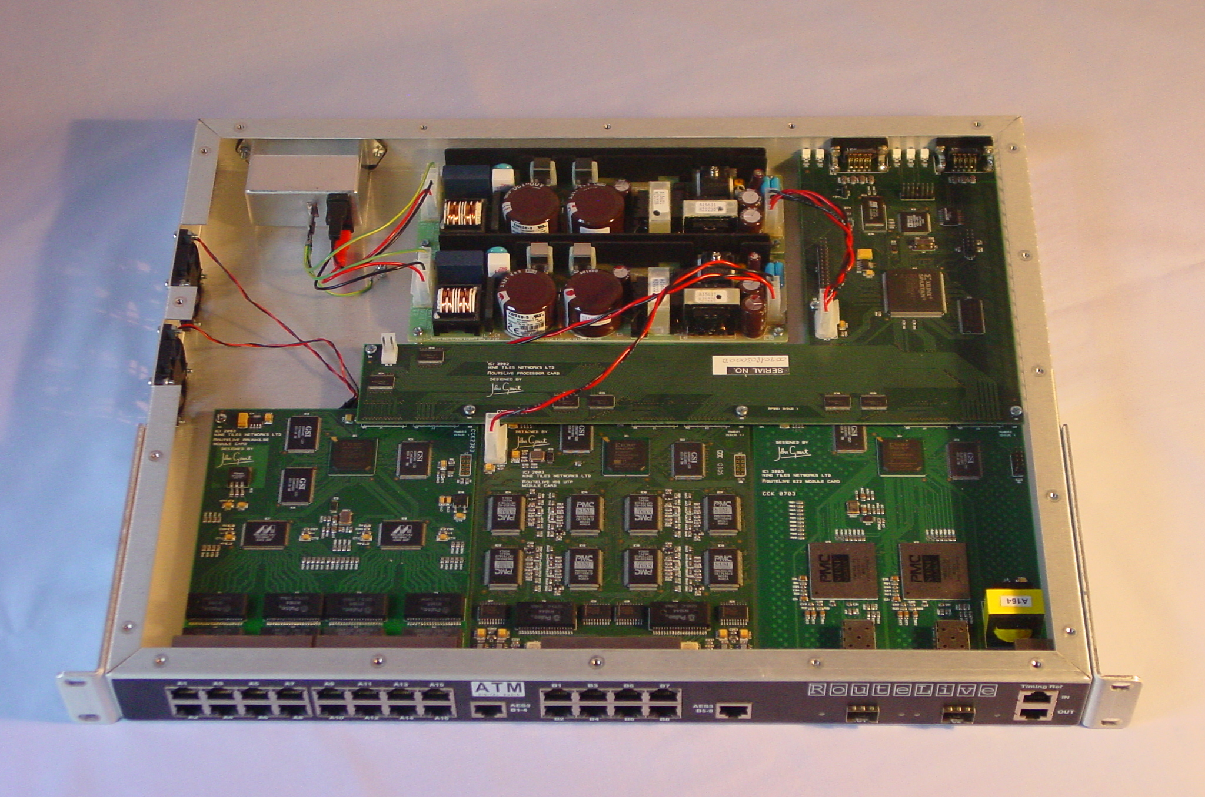

Nine Tiles Networks Ltd
9, Station Road,
Waterbeach,
Cambridge CB5 9HT
Tel: +44 1223 862599
http://www.ninetiles.com

