
Audiolink
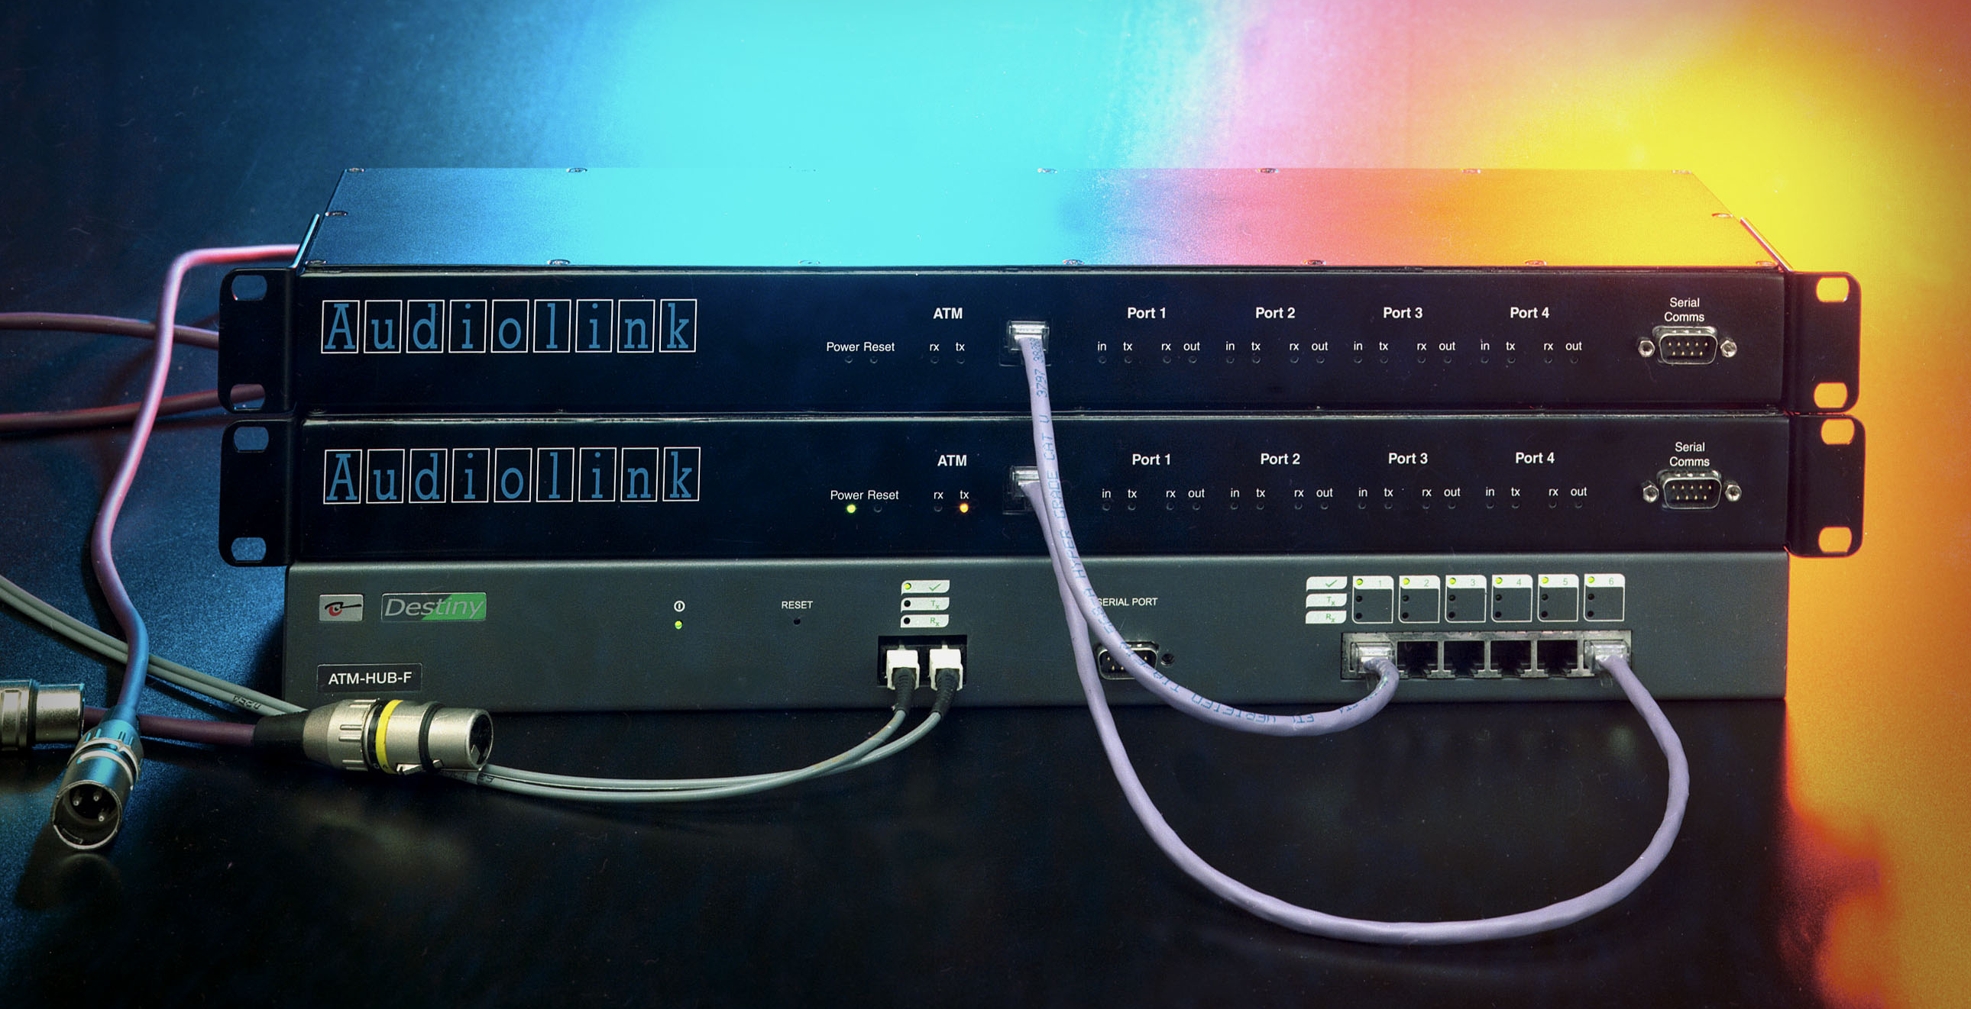
AES3 digital audio over ATM networks

• 4 input ports and 4 output ports in 1U-high enclosure
• sample rates up to 96 kHz
• output ports individually synchronised to source
• controlled via RS232 port or via a connection across the network
• control program for Windows 95/98 supplied
• easy to interface to user’s own control and routing software
• full ATM signalling stack for switched virtual circuit routing
• configurable for operation over “permanent” virtual circuits
• network connection over standard CAT3/CAT5 building wiring
Asynchronous Transfer Mode (ATM) is the most appropriate technology available now or in the foreseeable future for carrying live professional audio across public and private telecommunications networks. By using “native” ATM services instead of IP encapsulation, audio traffic benefits from
• guaranteed throughput, and
• minimum delays.
Audiolink units provide the connection between professional audio systems and the ATM network.

AL01 Specification

Mechanical
1U high 19” rackmount enclosure
Depth 150mm
Four AES3 input ports (back panel)
3-pin XLR connector
Sample rates: 96, 88.2, 64, 48, 44.1, 32, 24, and 22.05 kHz and these rates × 1000/1001
Configurable for autodetect or fixed sample rate
Four AES3 output ports (back panel)
3-pin XLR connector
Sample rates: 96, 88.2, 64, 48, 44.1, 32, 24, and 22.05 kHz and these rates × 1000/1001
Each port individually synchronised to its audio source; other synchronisation schemes available on request
Power inlet (back panel)
Fused & switched IEC connector
100-240V AC, 50/60Hz, <50W
RS232 port (front panel)
9-pin D-connector, pinout as PC comms port (RxD, TxD, DTR, CTS only)
Audiolink control protocol at 38,400 baud, 8 data bits + even parity
Configurable for “transparent” data for communication with local equipment
Other protocols available on request
ATM interface (front panel)
25 Mbit/s ATM UNI (RJ45 connector)
Indicators (front panel)
Power on; reset; ATM rx; ATM tx
For each input port:; ATM cells being transmitted
For each output port: ATM cells being received; audio present on AES3 output
Audio format on ATM network
CBR service, “native ATM” format
Input ports configurable for 24 or 24+8 bits per sample, mono or stereo
Other formats when AES standard is defined
Output ports configured automatically at call setup

Nine Tiles Networks Ltd,
The Old Sunday School, Chapel Street, Waterbeach, Cambridge, England CB5 9HR
Telephone +44 1223 862599
Web: www.ninetiles.com

